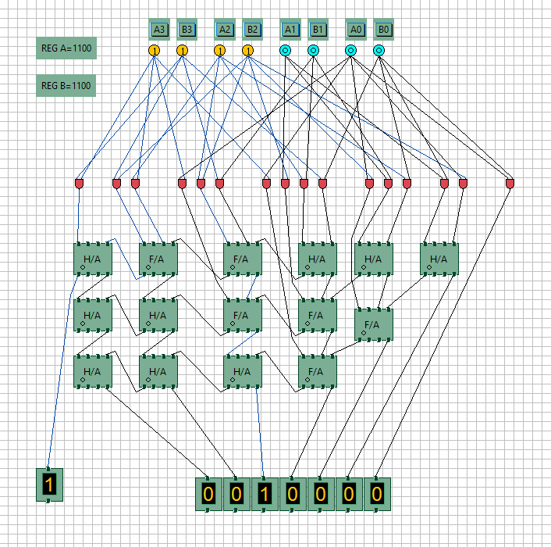
FIG1: INPUTS:A=1100,B=1100 OUTPUT: SUM=0010000 CARRY:1

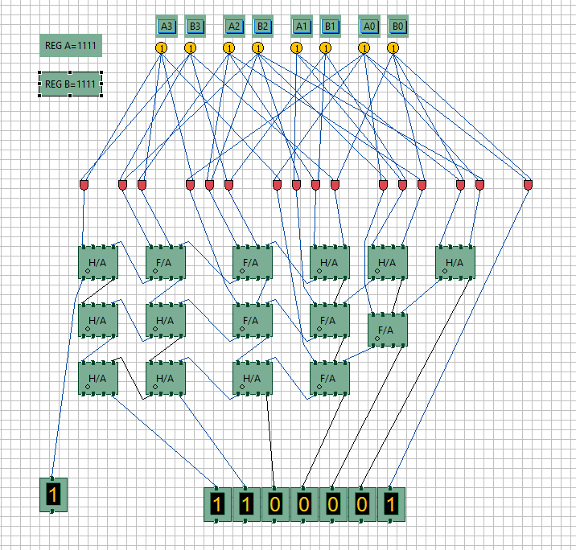
FIG2: INPUTS:A=1111,B=1111 OUTPUT: SUM=1100001 CARRY:1

